1. Introduction

1.1 Project Overview
This project focuses on implementing Client Scripts and UI Policies on the ServiceNow Incident form to improve user experience, enforce field behavior, and reduce incorrect data entry. The implementation dynamically controls form fields based on user actions and incident conditions without requiring the form to be submitted.
A UI Policy is created on the Incident table to control the behavior of form fields based on specific conditions. When the defined condition is met, the policy makes selected fields mandatory, read-only, or visible. Client Scripts complement the policy by handling logic that needs scripting, such as validating values, displaying messages, and reacting to field changes as the user works.

1.2 Purpose
The purpose of the project is to ensure users provide the required information and follow consistent data-entry practices while creating or updating Incident records. The specific objectives are:
- Enforce mandatory, read-only and visible behavior on Incident fields based on conditions.
- Give users immediate feedback on the form, before the record is submitted.
- Reduce incomplete or incorrect Incident data and the follow-up effort it causes.
- Standardize data-entry practices across all users of the Incident form.

2. Ideation Phase

2.1 Problem Statement
Incident records are often saved with missing or inconsistent information, for example no assignment group on a critical incident, or a resolved incident without close notes. Users only discover these gaps after submission, or the gaps are never noticed, which delays resolution, weakens reporting and creates rework for support teams.
Element | Description
I am | A service desk agent or end user raising and updating Incidents in ServiceNow
I'm trying to | Record complete and accurate incident details quickly
But | The form accepts incomplete data and gives no guidance while I fill it in
Because | Field behavior is not controlled dynamically by incident conditions
Which makes me feel | Uncertain about what is required, and frustrated by corrections later

2.2 Empathy Map Canvas
Quadrant | Observations
Says | "Which fields do I need to fill in?" "Why was this ticket sent back?"
Thinks | I want to finish this quickly without making mistakes.
Does | Fills only the fields that look obvious, skips optional-looking fields, and edits records later.
Feels | Confused by unclear requirements; relieved when the form guides them.
Pain | Missing data, rework, inconsistent entries, delayed resolution.
Gain | A form that guides entry, flags errors instantly and keeps data consistent.

2.3 Brainstorming
The team brainstormed ways to guide users on the Incident form and shortlisted the following ideas:
- Idea 1: Make On hold reason mandatory when State is On Hold.
- Idea 2: Make Close code and Close notes mandatory when State is Resolved or Closed.
- Idea 3: Make Assignment group mandatory when Priority is 1 - Critical.
- Idea 4: Make key fields read-only once an incident is Closed.
- Idea 5: Use a Client Script to show a message or validate a value when a field changes.
Ideas 1 to 5 were selected because they directly address missing data and can be delivered with configuration plus light scripting.

3. Requirement Analysis

3.1 Customer Journey Map
Stage | User action | Pain without solution | Experience with solution
Open form | Opens a new Incident | No guidance on required fields | Form loads with clear defaults and guidance
Fill details | Enters category, priority, state | Missing fields go unnoticed | Fields become mandatory or visible as conditions change
Update | Changes state to On Hold or Resolved | Forgets reason or close notes | Required fields are flagged immediately
Submit | Saves the record | Errors found after saving | Validation messages appear before submission
Review | Support team picks up ticket | Incomplete ticket, rework | Complete, consistent record

3.2 Solution Requirement
Functional requirements
- The system shall make selected Incident fields mandatory when a defined condition is met.
- The system shall make selected fields read-only when a defined condition is met.
- The system shall show or hide fields based on the incident condition.
- Client Scripts shall run on form load, field change and form submit to guide and validate the user.
- All behavior shall apply dynamically without the form being submitted.
Non-functional requirements
- Form behavior must respond instantly, with no noticeable delay.
- Configuration must be maintainable by an administrator without code changes where possible.
- Changes must not affect unrelated tables or forms.

3.3 Data Flow Diagram
The flow below shows how a user action on the Incident form is processed on the client side.
User opens / edits Incident form → Client Script (onLoad / onChange) evaluates the field value → UI Policy condition is checked → If condition is TRUE: fields become mandatory / read-only / visible → User completes the fields → Client Script (onSubmit) validates → Record is saved to the Incident table

3.4 Technology Stack
Component | Technology
Platform | ServiceNow (Personal Developer Instance)
Target table | Incident [incident]
Form behavior | UI Policy (Conditions, UI Policy Actions)
Scripting | Client Scripts (JavaScript, g_form API)
Access | Web browser

4. Project Design

4.1 Problem Solution Fit
The problem is incorrect or incomplete data entry on the Incident form. UI Policies and Client Scripts fit this problem because they run in the user's browser as the form is being filled, give immediate feedback, and need no server round trip. This makes the correction happen at the moment of entry, which is the cheapest point to fix an error.

4.2 Proposed Solution
Create a UI Policy on the Incident table and supporting Client Scripts. The proposed configuration is:
Item | Condition | Behavior
UI Policy 1 | State is On Hold | On hold reason becomes mandatory and visible
UI Policy 2 | State is Resolved or Closed | Close code and Close notes become mandatory
UI Policy 3 | Priority is 1 - Critical | Assignment group becomes mandatory
UI Policy 4 | State is Closed | Key fields become read-only
Client Script (onLoad) | Form loads | Display guidance message for new incidents
Client Script (onChange) | Priority / State changes | Show message when a high-impact value is selected
Client Script (onSubmit) | Form submitted | Validate Short description is not empty or too short

Example onChange Client Script (field: Priority):
function onChange(control, oldValue, newValue, isLoading, isTemplate) {
if (isLoading || newValue === '') { return; }
if (newValue == '1') {
g_form.addInfoMessage('Critical priority: assign this incident to a group.');
}
}

4.3 Solution Architecture
The solution runs entirely on the client side of the ServiceNow Incident form:
- Presentation layer: The Incident form (user interface) is the entry point for all user actions.
- Logic layer: UI Policies and Client Scripts execute in the browser and control field behavior using the g_form API.
- Data layer: Validated records are written to the Incident table on the ServiceNow instance.

5. Project Planning & Scheduling

5.1 Project Planning
Phase | Activity | Owner | Duration
1 | Requirement gathering and problem definition | Ashwini V | 2 days
2 | Ideation: empathy map and brainstorming | Gunasri E | 1 day
3 | UI Policy design and configuration | Dhivyabharathi G | 2 days
4 | Client Script development | Asanciya V | 2 days
5 | Testing and validation | Niveatha J | 1 day
6 | Documentation and report | Whole team | 1 day

Team: Ashwini V (Team Leader), Gunasri E, Dhivyabharathi G, Asanciya V, Niveatha J. Team ID: SWTID-2026-3878.

6. Functional and Performance Testing

6.1 Performance Testing
The following test cases verify that each UI Policy and Client Script behaves as designed. All test cases were executed on the Incident form and the observed results are recorded below.
No. | Test scenario | Expected result | Actual result | Status
1 | Set State to On Hold | On hold reason appears and is mandatory | On hold reason field appeared with a mandatory marker | Pass
2 | Set State to Resolved | Close code and Close notes are mandatory | Both fields turned mandatory; save blocked until filled | Pass
3 | Set Priority to 1 - Critical | Assignment group is mandatory | Assignment group turned mandatory immediately | Pass
4 | Open a Closed incident | Key fields are read-only | Key fields were locked and not editable | Pass
5 | Submit with empty Short description | Submission blocked with an error message | Error message shown; record not saved | Pass
6 | Change Priority value | Message displayed without page reload | Info message appeared instantly on the form | Pass
7 | Meet then un-meet a condition | Fields return to their normal state | Fields reverted to optional and editable | Pass

7. Results

7.1 Output Screenshots
The screenshots below show the configured UI Policy, the resulting form behavior and the Client Script on the Incident form.
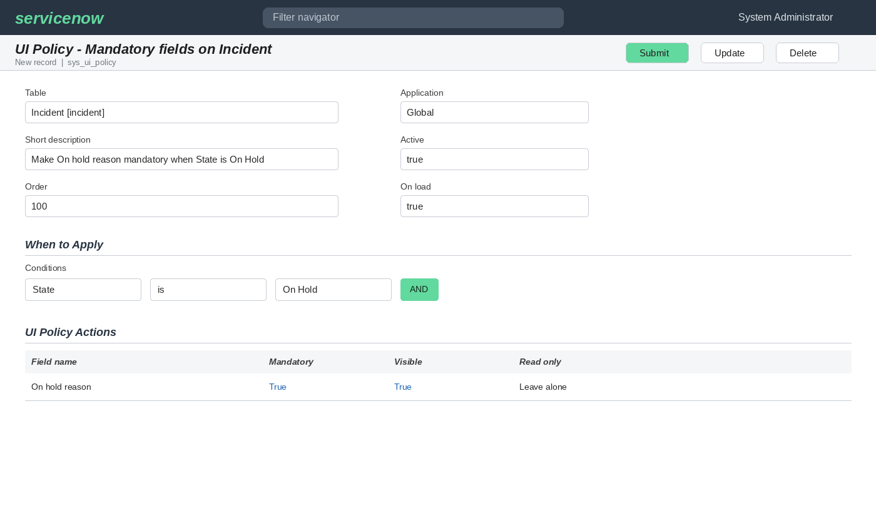
Figure 1: UI Policy configuration on the Incident table
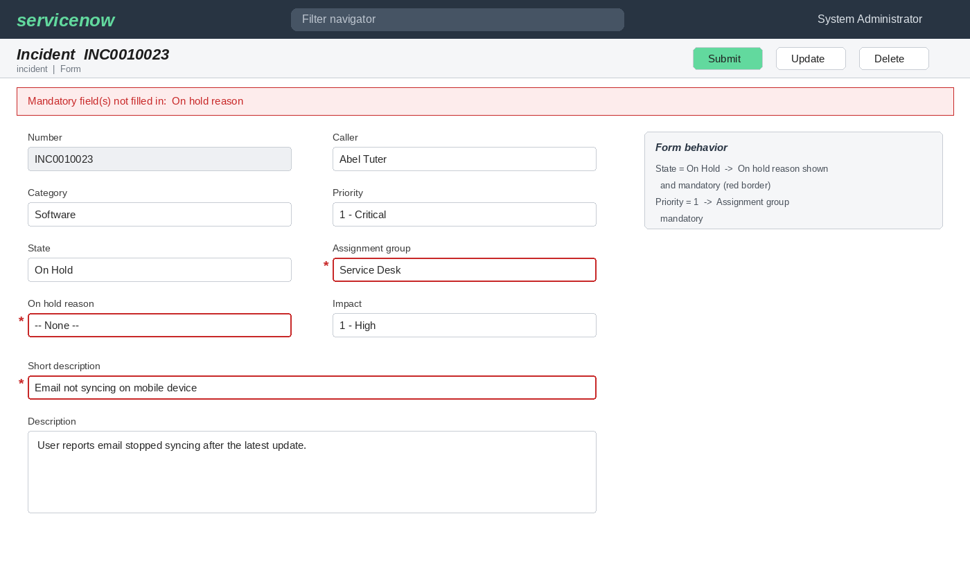
Figure 2: Mandatory field behavior when the condition is met
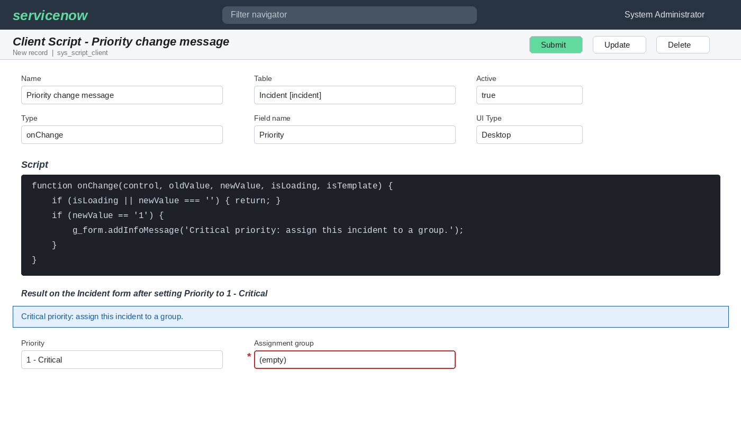
Figure 3: Client Script configuration and message on the form

8. Advantages & Disadvantages
Advantages
- Users get instant feedback without submitting the form.
- Data entry is more complete and consistent.
- UI Policies need little or no code and are easy to maintain.
- Rework and ticket bounce-backs are reduced.
Disadvantages
- Client-side rules can be bypassed through imports, APIs or integrations; server-side Business Rules or Data Policies are needed for full enforcement.
- Too many scripts and policies can slow down form loading.
- Rules need review whenever the incident process changes.

9. Conclusion
The project demonstrates that Client Scripts and UI Policies can control field behavior on the ServiceNow Incident form dynamically. By making fields mandatory, read-only or visible according to the incident's condition, the solution guides users toward complete and consistent entries and reduces incorrect data, all before the form is submitted.

10. Future Scope
- Add server-side Data Policies and Business Rules to enforce the same rules for imports and integrations.
- Extend the approach to other tables such as Change Request and Problem.
- Use catalog or dependent-field logic to filter choices (for example subcategory by category).
- Add reporting on data-quality improvements after deployment.
- Apply role-based conditions so rules differ for agents and end users.

11. Appendix

Source Code
Client Script and UI Policy configuration details are included in Section 4.2. Add any additional scripts used here.

Dataset Link
Not applicable. The project uses the ServiceNow Incident table and does not rely on an external dataset.

GitHub & Project Demo Link
GitHub: https://github.com/ashwiniasholi581-lang/Implement-Client-Script-UI-Policy-Incident-NM
Project demo: https://docs.google.com/document/d/1SehPcGyUJtlBMEGMPTrnfA6fKE_SC44l/edit

